The settings that we need to change

Technologies that have been used.

* MSSQL Database
* Visual Studio 2019

Entity Framework(6.4.4)

Microsoft.EntityFrameworkCore.SqlServer (5.0.17)

Microsoft.EntityFrameworkCore.SqlServe.Design(1.1.6)

Microsoft.EntityFrameworkCore.Tools (5.0.8)

Microsoft.EntityFrameworkCore.Mvs.RuntimeCompilation(5.0.17)

Microsoft.VisualStudio.Web.CodeGeneration.Design(5.0.2)

* Database Migration

Add-Migration Data/Migrations

Update-Database

Screenshots of the interfaces

Employee Insert Form

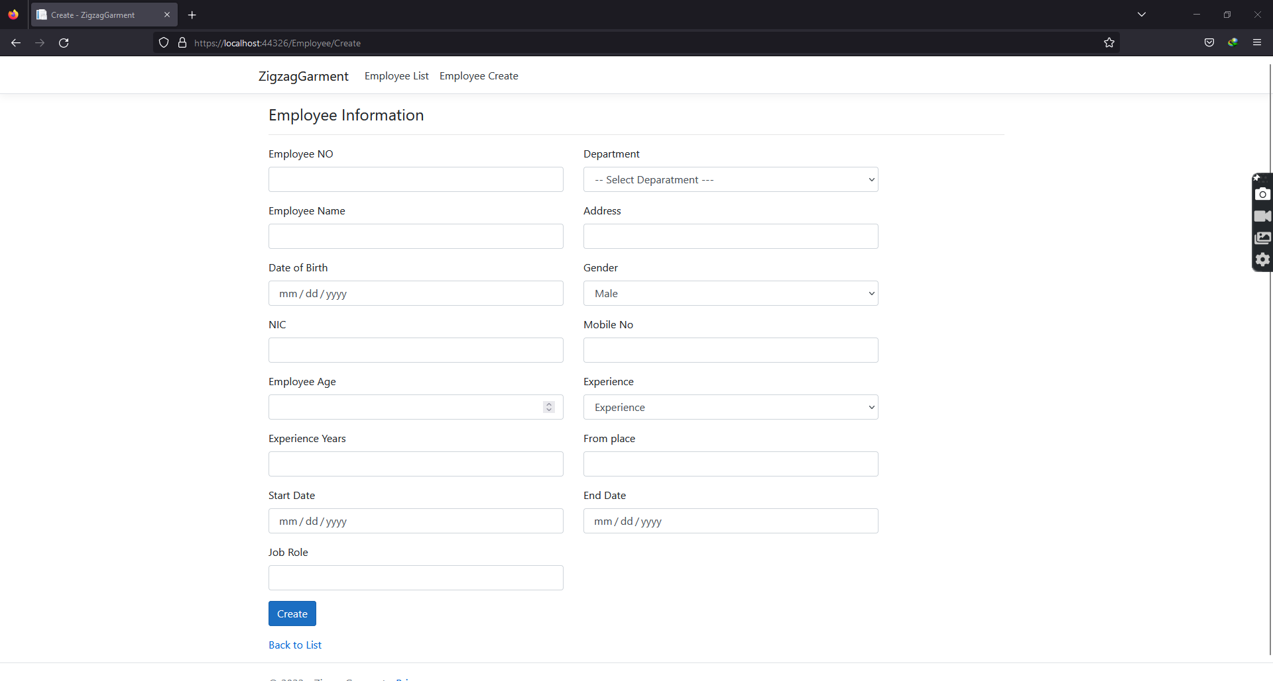

Employee List View

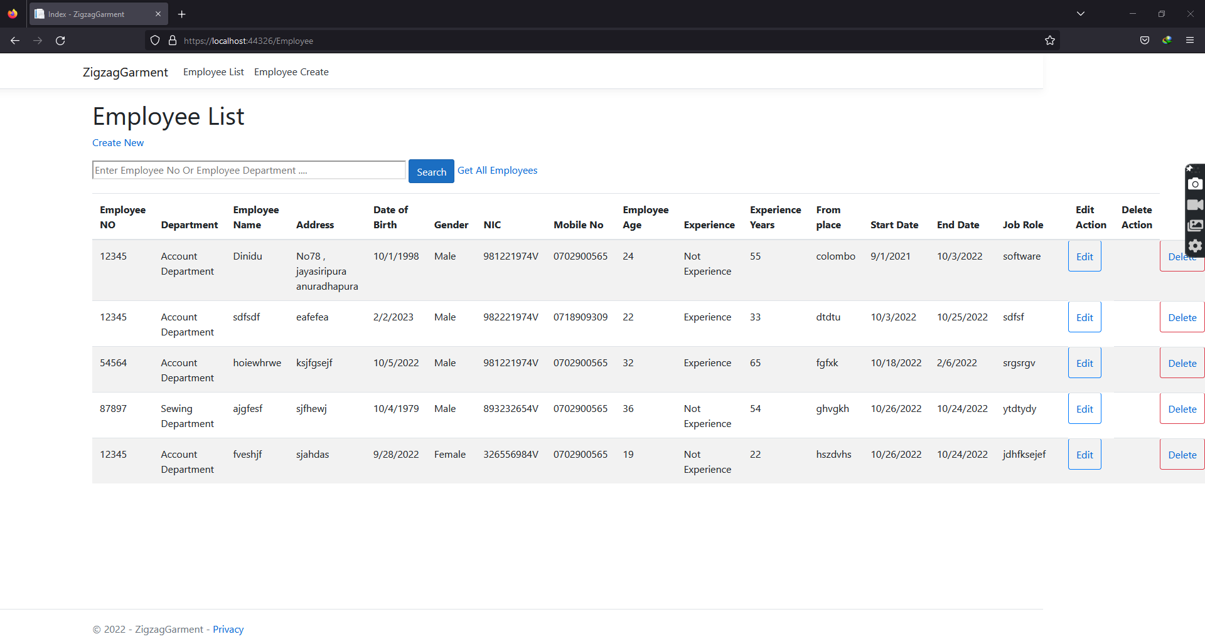

Employee Edit Form

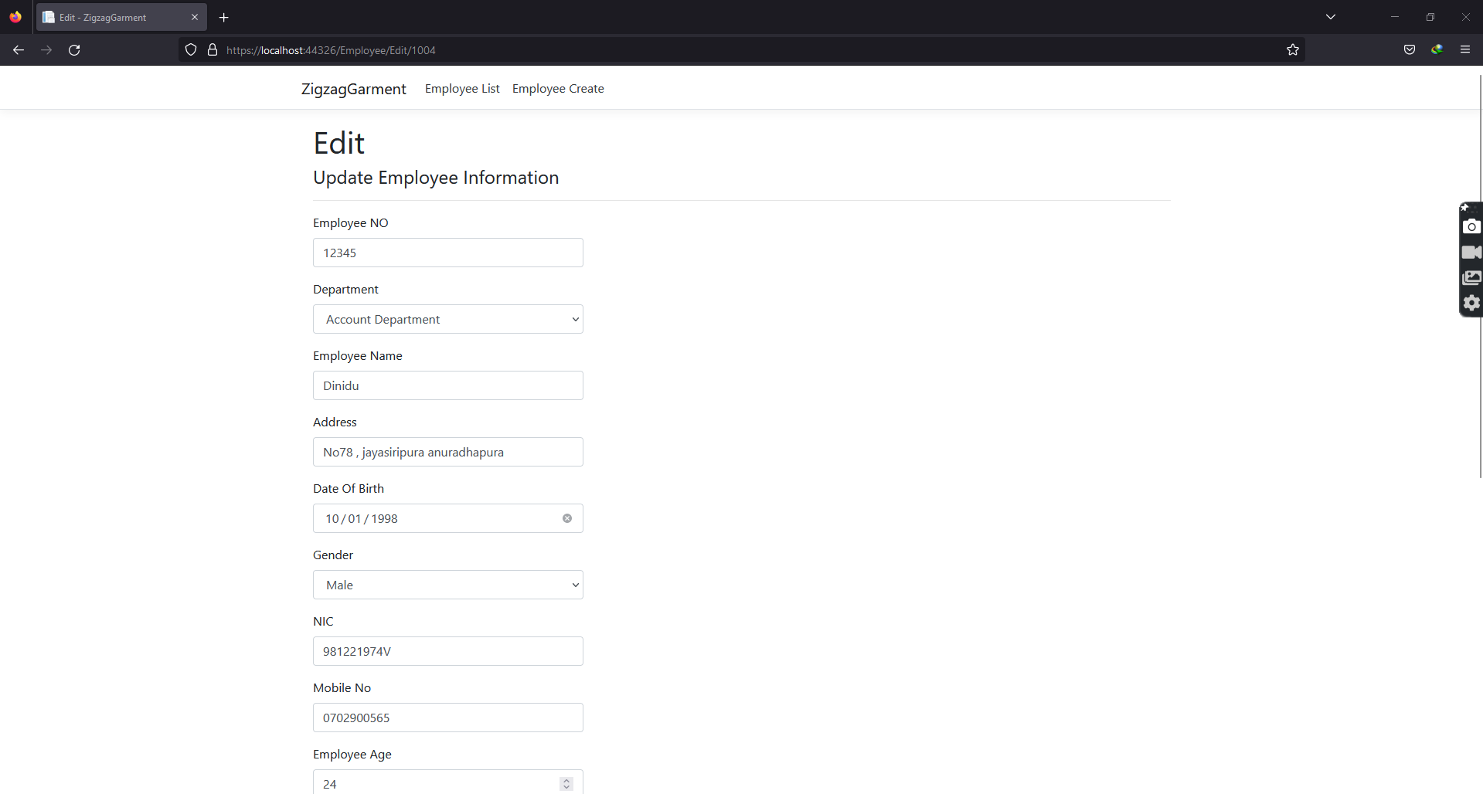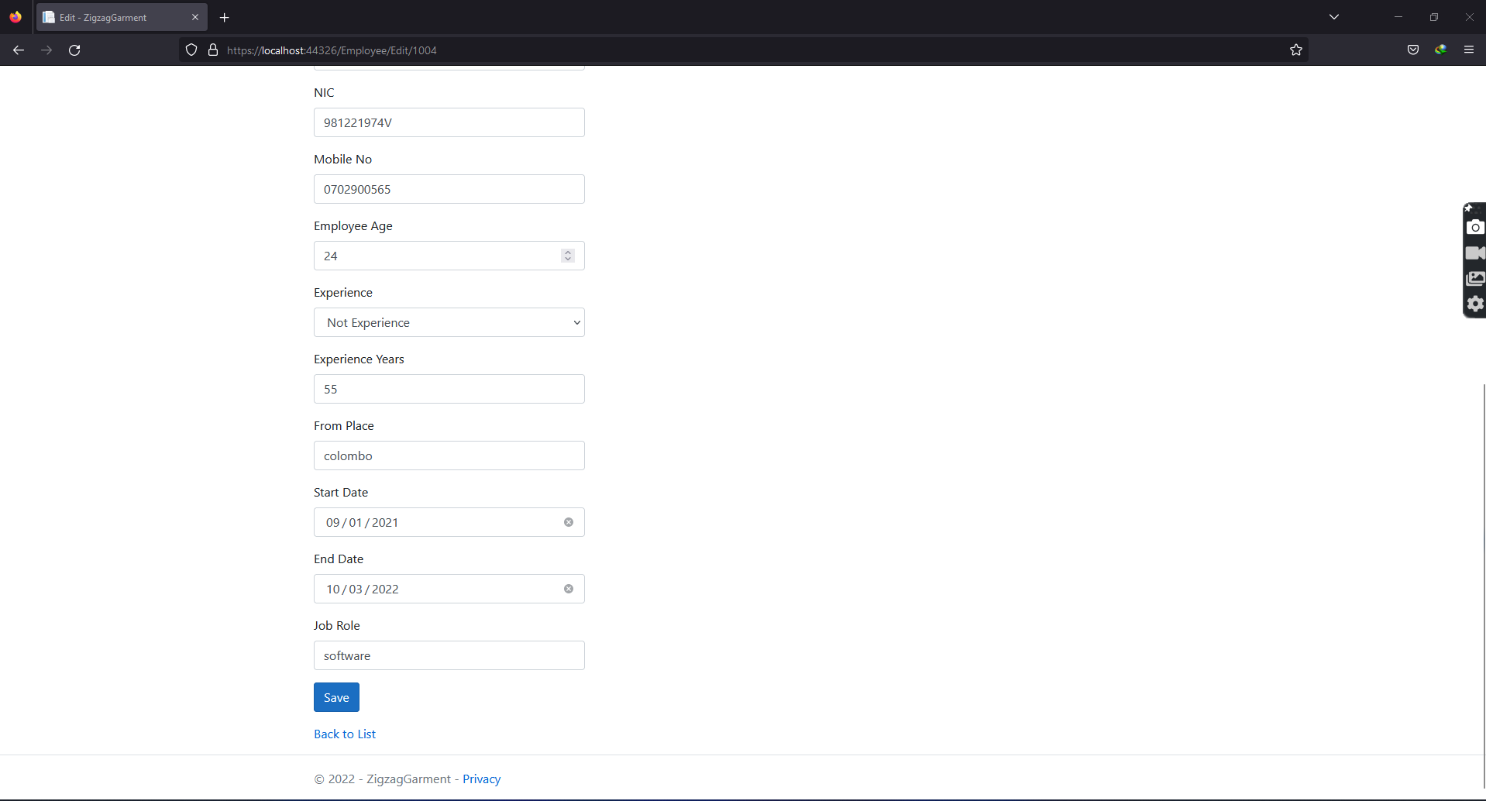

Employee Delete

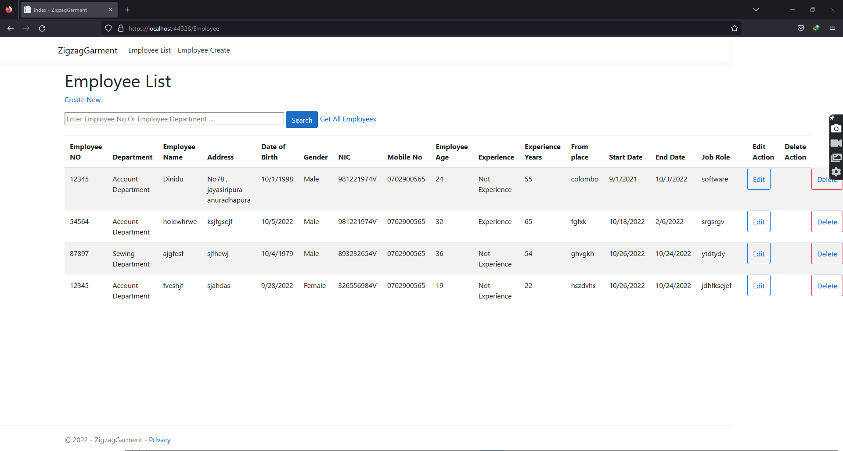

Employee Search

